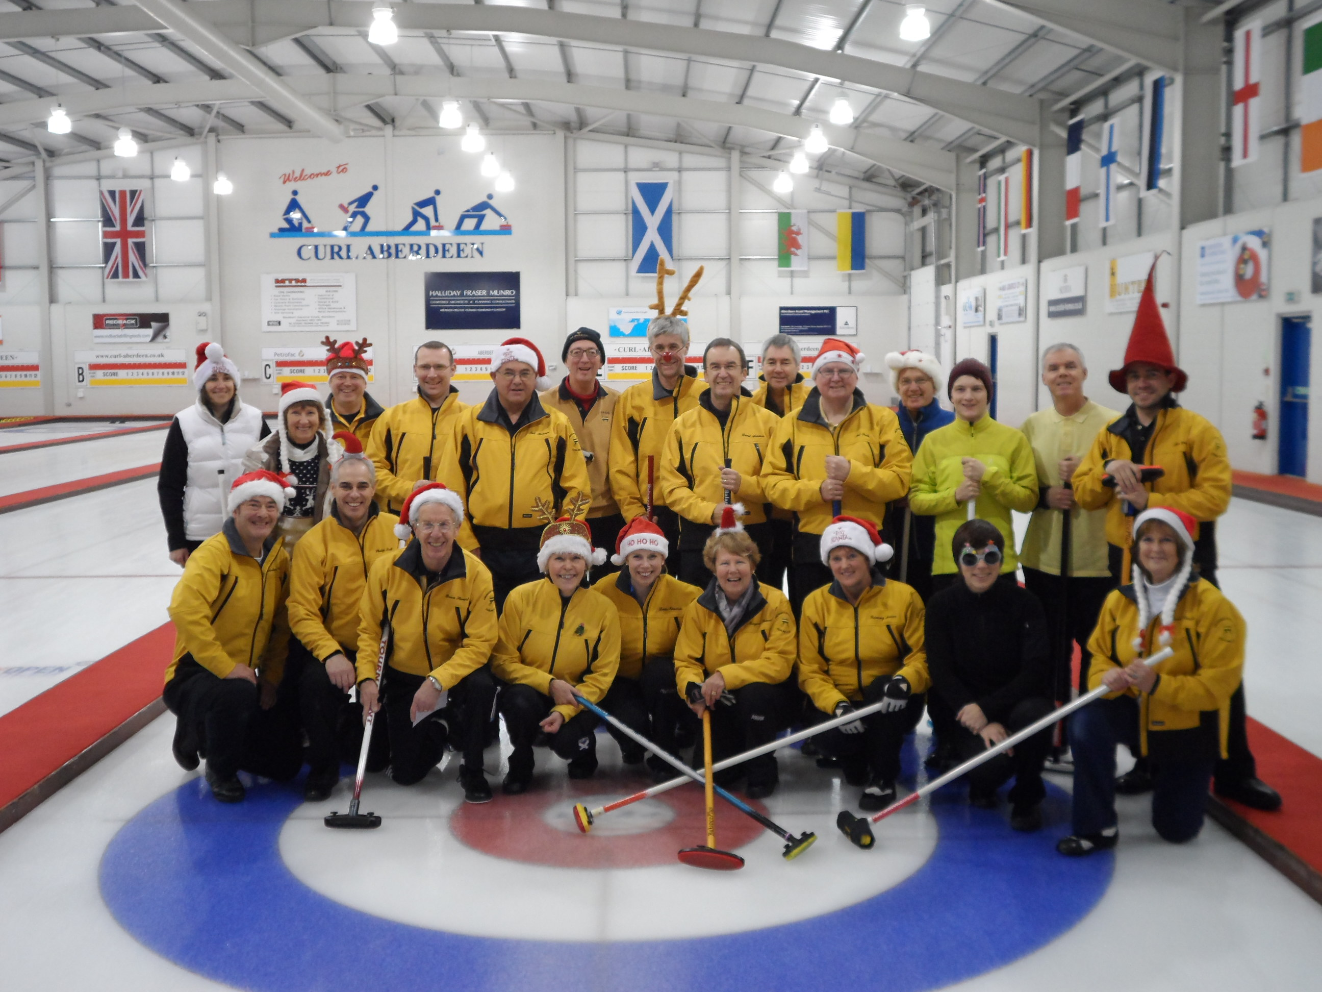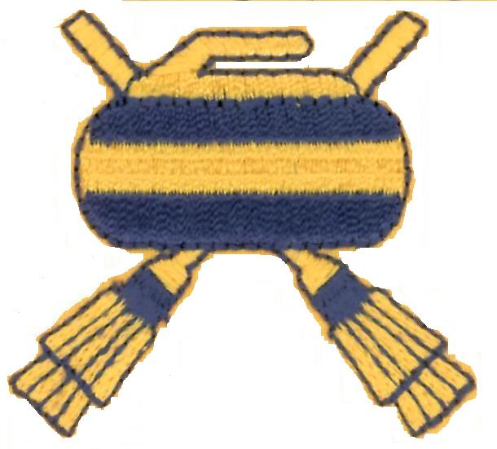 **Aberdeen Petroleum Curling Club**

**Information for New Members**

This sheet contains information that new or potential curlers may find useful. The club welcomes new members of all ages and abilities.

Curling is a traditional Scottish sport which has been exported around the world. Formerly popular on village ponds, it is now played mostly on indoor rinks, but still only from September to April each year. Teams comprise 4 players, and each player slides 2 granite stones down the ice "sheet" in each "end". A game usually comprises 8 ends and lasts about 2 hours. The aim is to end up with your team's stones closer to the centre of the "house" than the opponents' stones. A mixture of tactics and skill, curling has been called "chess on ice", and it is not unknown for sweepers to work up a sweat due to the effort involved. The sport is governed by the Royal Caledonian Curling Club, and general information may be found at <http://royalcaledoniancurlingclub.org/> Since becoming an Olympic event in 1988 curling has benefited from increased TV and press coverage.

A large new curling facility was built in Aberdeen in 2005. Curl Aberdeen is located on the Lang Stracht, and provides coaching, corporate teambuilding, and refreshments as well as being the meeting place for local curlers. There is a map and rink information at <http://www.curl-aberdeen.co.uk/>

Aberdeen Petroleum Curling Club has about 50 members ranging from (relatively) young to (relatively) old and spanning all levels of ability from beginner to world champion. The club runs its own autumn and spring leagues and also participates in local and regional competitions. Teams generally have at least 5 players so that people do not need to guarantee their availability for every game. As a rough guide, new members might expect to play around 12 games in a season. We also organise one or two social events each season to which members and their partners are invited.

The best way to get involved is to attend a free “try curling” session. These are organised regularly by Curl Aberdeen. If you enjoy that, the next step is to attend a beginners’ class (4 x 2hr sessions) - details of these may also be found on the Curl Aberdeen website. When you complete the course you can call yourself a curler and are ready to join the club and to play some games.

How much does it cost ?

* A rink membership fee (normally £50 per year, reduced to £10 in first season)
* A club membership fee (normally £32 per year, reduced to £10 if you join late in the season). Note : this covers RCCC affiliation and insurance.
* An ice fee each time you play (currently £12 per game)
* Clothing and Equipment (initially not required, just wear warm loose fitting clothes and wear clean trainers. You may choose to invest in special shoes and a brush at a later date).

If you would like to join please contact the club secretary (below). He will be happy to answer any questions you may have and to welcome you into the club. Good curling.

Malcolm Watson 07901 515212 watsonmd@btinternet.com