**Indoor Grand Match 2010**

Dillan Perras led the APCC team for the indoor Grand Match on 23rd October 2010 at Kircaldy rink.  Other members of the Aberdeen team were Iseabal, Richard, and Malcolm. Our opponents were the Sorn club from Ayrshire and APCC came away with an 11-6 victory. The Match was won overall by the South.

[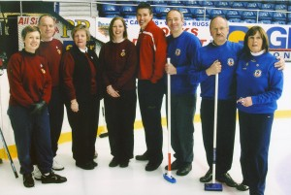](http://network.royalcaledoniancurlingclub.org/aberdeen-petroleum-curling-club/files/2015/02/kirkcaldy2.jpg)

